RAJALAKSHMI ENGINEERING COLLEGE
An Autonomous Institution, Affiliated to Anna University
Rajalakshmi Nagar, Thandalam – 602 105

WEB TECHNOLOGY AND MOBILE APPLICATION
Experiment – 04
2025-26

By
NIJANTHAN V
B-TECH AI&DS
2116241801185

Expt.NO: 04 DATE:
Create a web form that accepts a user's name and age. Write a Servlet to process the form data and display it back on the browser.
AIM:
To create a simple web application that includes a form to accept a user's name and age, and then use a Servlet to process the submitted data. The Servlet will retrieve the form data, process it, and display the values back on the browser.

ALGORITHM:
1. Input:
- The user fills out a web form with their name and age and submits it.
2. Form Handling and Servlet Processing:
- Create the Web Form:
  - Create an HTML form with two input fields: one for the user's name and one for the user's age.
  - Add a submit button to the form.
  - Set the form's action attribute to the URL of the Servlet and the method to POST (or GET).
- Create the Servlet Class:
  - Write a Servlet that processes the form data submitted by the user.
  - The Servlet will override the doPost() (or doGet() depending on the form method) to handle form submissions.
  - The Servlet will retrieve the name and age parameters from the request object using request.getParameter("name") and request.getParameter("age").
- Process the Data in the Servlet:
  - Extract the name and age values submitted from the form.
  - Validate the input (e.g., check if the age is a valid number).
  - Prepare a response that will display the user's name and age back on the browser.
- Send Response to the Browser:
  - The Servlet will send a response to the browser containing a message like:
    - "Hello, [name]! You are [age] years old."
  - The response will be displayed to the user in the browser.
- Deploy the Servlet:
  - Compile the Servlet and deploy it to a Servlet container (like Apache Tomcat).
  - Ensure the web.xml file or Servlet annotations are used to map the Servlet to the URL defined in the form's action attribute.
- Test the Application:
  - Open the web browser, fill in the form with the name and age, and submit it.
  - The Servlet will process the data and display the message back to the user in the browser.

CODE:

HTML:
<!DOCTYPE html>
<html>
<head>
<title>User Form</title>
</head>
<body>
<h2>User Form</h2>

<form action="UserForm" method="post">
Name:
<input type="text" name="username" required><br><br>

Age:
<input type="number" name="age" required><br><br>

<input type="submit" value="Submit">
</form>
</body>
</html>

SERVLET:
package com.demo;

import java.io.*;
import jakarta.servlet.*;
import jakarta.servlet.http.*;
import jakarta.servlet.annotation.WebServlet;

@WebServlet("/UserForm")
public class UserForm extends HttpServlet {

protected void doGet(HttpServletRequest request, HttpServletResponse response)
throws ServletException, IOException {

response.setContentType("text/html");
PrintWriter out = response.getWriter();

out.println("<html><body>");
out.println("<h2>Please submit the form</h2>");
out.println("</body></html>");
}

protected void doPost(HttpServletRequest request, HttpServletResponse response)
throws ServletException, IOException {

String name = request.getParameter("username");
String age = request.getParameter("age");

response.setContentType("text/html");
PrintWriter out = response.getWriter();

out.println("<html><body>");
out.println("<h2>User Details</h2>");
out.println("Name: " + name + "<br>");
out.println("Age: " + age);
out.println("</body></html>");
}
}

OUTPUT:

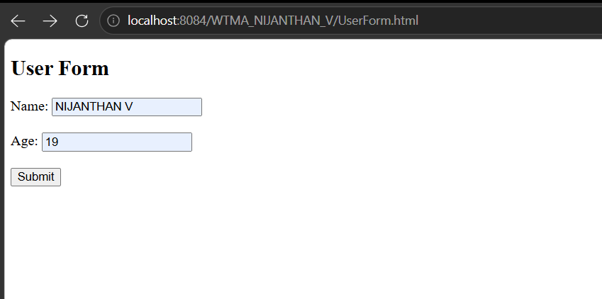
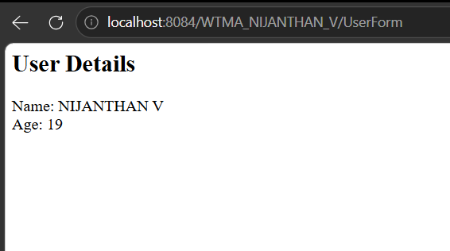

RESULT:
A Servlet is created to process the HTML form data and display it back on the browser.

